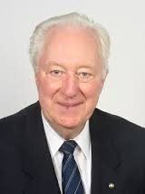
Nándor Richter, a good friend, a teacher devoted to help the handicapped, an engineer popularizing the achievements of technical progression, a leader to direct, guide, and lead national and international organizations, an open-minded citizen feeling like home anywhere in the world, passed away on 8th October, 2015.
He received his M. Phil. (mathematics and physics) in 1954 from Eötvös Loránd University, Budapest, and M.Sc. (electrical engineering) from Budapest Technical University in 1962. He also received the EUR ING title delivered by FEANI, created to recognize the competence of professional engineers.From 1954 he was a high school teacher, and in 1961 he joined the laboratory of electronic and nuclear measurements of the Hungarian National Office of Measures. From 1964 to 1991 (when he retired) he was with the Hungarian company Medicor, the largest medical equipment company in Central Europe. He was head of the product development and design laboratory. He also worked for several years in South America as a company representative.

From 1977 until 1993 he worked in several developing countries as a UN as well as independent expert in the field of health-related technical activities. He also worked as an expert for project evaluations in the EU and for UN agencies (UNIDO, WHO). He joined the Institute for Hospital and Medical Engineering (ORKI) in 1990 as a part-time Senior Advisor for Biomedical Engineering.

His IFMBE activities date back to the 1970s. As a result of his efforts, the Hungarian BME Society (Biomedical Engineering Section of the Scientific Society for Measurement, Automation and Informatics, MATE) joined IFMBE as the 18th national society in 1973. He was president of the BME Society of MATE between 1994 and 2003 and honorary life member since then.

He was President (1985 – 1988) of IFMBE and served as Vice President of International Union for Physical and Engineering Sciences in Medicine (1988 - 1991). He is a Founding Fellow of the International Academy for Medical and Biological Engineering, and a Board Member of the Hungarian Academy of Engineering.

In the period 1990 - 1994 he took active part in the organization of meetings supporting East-West European collaboration in the profession, including the co-organization of the first International Conference on Medical Physics Education (Budapest, 1994).
His professional activities were honored by the Kolos Richard Award, Csáki Frigyes Memorial Medal and Dr. Katona Zoltán Medal. He is an Honorary Life Member of IFMBE, of the Biomedical Engineering Society of the Czech Purkinje Scientific Association, and of MEDING (Hungarian National Society of Medical Engineering).
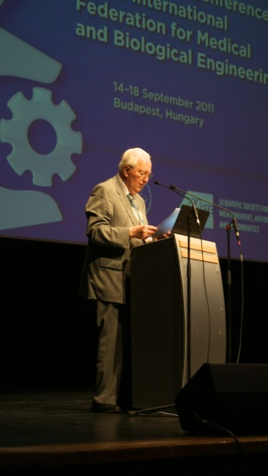
At the Opening Ceremony, EMBEC 2011.
In the 1980s he participated in the reorganization of the Rotary movement in Hungary, and he is founding member of the Budapest Rotary Club (President between 1996 – 1997). He promoted the journal Természetvilága (World of Nature) and related to it brought into being a program to support talented young persons.
We will painfully miss his help, good humor and optimism.
Ákos Jobbágy
Nándor was the most diplomatic person I have ever met. When the Working Group on Clinical Engineering became a Clinical Engineering Division, Nándor was instrumental in ensuring that it would be created and develop. This was a major feat considering the time (1985) and some of the complicated politics surrounding this major innovation. Through his vision and leadership skills, all was well and the Division is still very active today.
My most cherished memory of Nándor is when he and two colleagues visited me and my department in Moncton in the mid-1980s, a regional clinical engineering service for south eastern New Brunswick. It was part of a North American Tour about clinical engineering and medical devices. After visiting our hospitals and laboratory, we had a meeting with our staff, Nándor, and his colleagues at the Chalet of the Moncton Hospital. We cooked lobster and had a wonderful picnic in addition to a fruitful meeting. He really enjoyed this experience and I can still hear his voice and his laugh which was so contagious. Nándor was so kind, brilliant, a Renaissance engineer! He will be sorely missed!
Monique Frize

Nándor was a unique person, able to soften any atmosphere and made anyone comfortable. I remember the EMERALD Workshop on Medical Physics Training in Prague, which I organized in 2000 with representatives from 19 countries (mainly from Central/Eastern Europe). Although known by email, most colleagues had not seen each other before. At the evening, in a local pub, Nándor’s natural humor, benevolence and diplomacy made its wonders and in an hour we all felt like a family. Next day almost all were under the effect of the previous evening and the work moved quickly and easily. Later, at an IFMBE meeting in London, he was again at the heart of the meeting, with his exceptional diplomatic leadership, and nobody understood how the difficult questions were not such anymore. I had the privilege to know Nándor’s fantastic family and to have his advice at several moments of my career. These were always wise, professional and effective - for what I shall always be grateful to him. Nándor was not only a brilliant medical engineer and leader, but also one of those outstanding people who change the world around without much noise and leave it better for all of us. He will be missed by all our professional community!

Slavik Tabakov

